Contents

1. Infrastructure Planning 2

1.1 Proper infrastructure planning is critical to cloud migrations. Considerations migrating to cloud include: 2

1.2 Infrastructure should be planned properly for all multiple services 2

2. DevOps 3

2.1 DevOps teams work by utilizing continuous integration software delivery 3

2.2 DevOps is a cross foundational infrastructure team supporting development, QA, and operations 3

3. Cloud automation 4

4. Desired State Configuration (DSC) 4

4.1 Declarative model for system configuration management 4

5 Azure Resource Manager (ARM) 4

5.1 ARM Capabilities 4

5.2 Azure Resource Templates 5

5.3 Resource Groups 5

6. PowerShell 6

8. References 7

# 1. Infrastructure Planning

## 1.1 Proper infrastructure planning is critical to cloud migrations. Considerations migrating to cloud include:

* Cost, Disaster Recovery, Availability, Efficiency, Scalability, and Reliability

## 1.2 Infrastructure should be planned properly for all multiple services

* Application development, IT operations, legal, finance, procurement, security, compliance, privacy, identity management, data integration, mobility, customer experience, and business development

Figure 1.3 – Cloud Migration Process Diagram

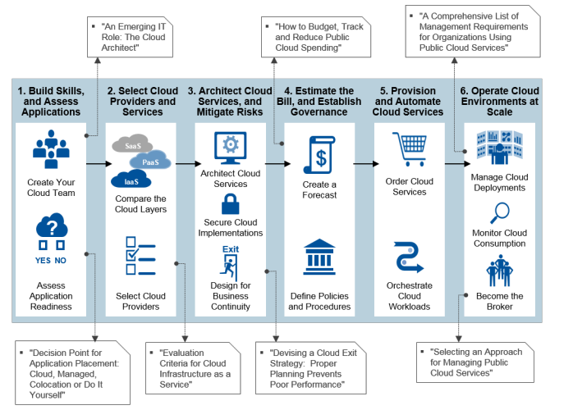

# 2. DevOps

## 2.1 DevOps teams work by utilizing continuous integration software delivery

* Code, Build, Test, Package, Release, Configure, Monitor

## 2.2 DevOps is a cross foundational infrastructure team supporting development, QA, and operations

Figure 2.21

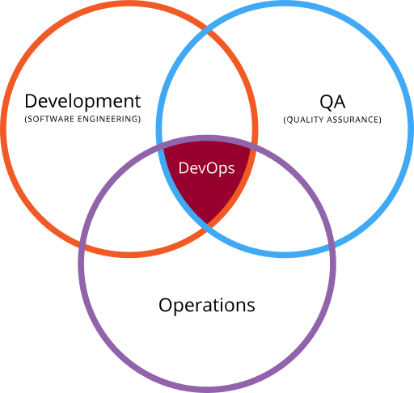

# 3. Cloud automation

* Spend less time on infrastructure and more time on business services
* Reduce human errors
* Create a repeatable process

# 4. Desired State Configuration (DSC)

## 4.1 Declarative model for system configuration management

* Simplify system administration task by configuring one or more devices automatically
* Configure machines identically for standardization
* Keep systems in sync to avoid drift
* Deployment on demand
* Works alongside other configuration management tools such as Chef or Puppet

Figure 4.11

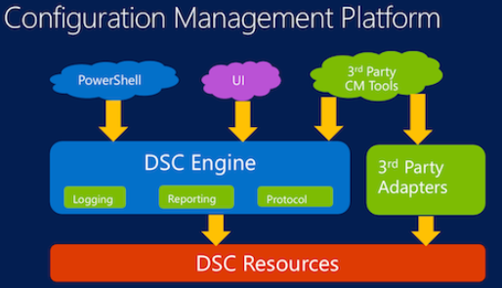

# 5 Azure Resource Manager (ARM)

## 5.1 ARM Capabilities

* Deploy, manage, and monitor all the services for your solution and application as a group
* Continuous deployment allows your solution to have a consistent state throughout the development lifecycle
* Apply access control to all resources in your resource group
* Apply tags to resources to logically organize them holistically
* Use pre-existing JSON templates to manage resources and groups

## 

## 5.2 Azure Resource Templates

* JSON files that define the resources you need to deploy your solution
* Use tooling such as Visual Studio with Azure SDK or Visual Studio Code to create JSON templates
* Define $schema, contentVersion, parameters, variables, resources, and outputs
* You can find a list of Quickstart templates [here](https://azure.microsoft.com/en-us/resources/templates/)

Figure 5.21

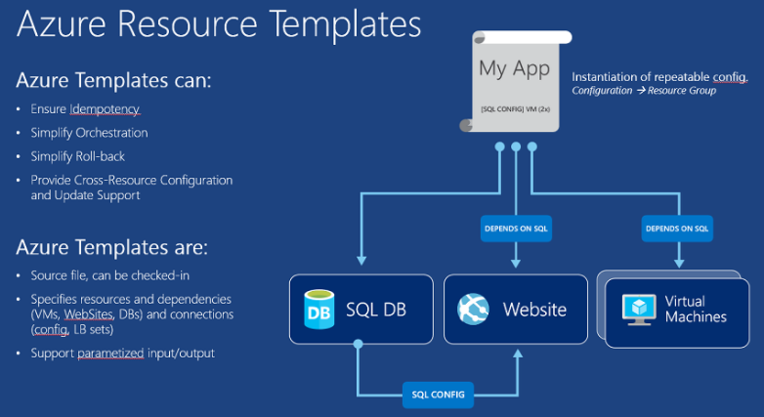[3]

## 5.3 Resource Groups

* Monitor, control access, provision, and manage billing for a collection of assets that are required to run an application.

Figure 5.31

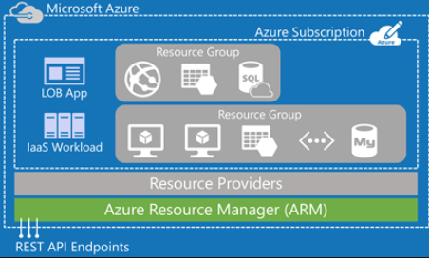

# 6. PowerShell

* Task automation and configuration management framework from Microsoft
* PowerShell ISE Integrated Scripting Environment tool available for multiple commands and script writing
* Manage remote resources and script configuration management DSC.

Figure 6.1 Example PowerShell script

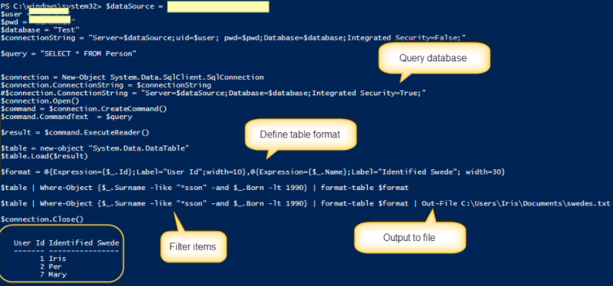

# 8. References

* [Header Image](https://www.google.com/url?sa=i&rct=j&q=&esrc=s&source=images&cd=&cad=rja&uact=8&ved=0ahUKEwj825uM2rTXAhVI1WMKHdXgBlIQjRwIBw&url=https%3A%2F%2Fwccftech.com%2Fdev-confirms-power-microsofts-azure-cloud-explains-developers-reclutant%2F&psig=AOvVaw3jdXnrEM-o7Yft7KvD8xaA&ust=1510427134275660)
* [Figure 1.3 Infrastructure Planning](https://www.gartner.com/binaries/content/assets/events/keywords/catalyst/catus8/2017_planning_guide_for_cloud.pdf)
* [Figure 2.21 DevOps](https://en.wikipedia.org/wiki/DevOps)
* [Figure 4.11 Desired State Configuration](https://www.google.com/url?sa=i&rct=j&q=&esrc=s&source=images&cd=&cad=rja&uact=8&ved=0ahUKEwjS0_mss7XXAhVF82MKHZ_nDy8QjRwIBw&url=https%3A%2F%2Fwww.infoq.com%2Fnews%2F2014%2F05%2Fpowershell-dsc-takes-on-linux&psig=AOvVaw0613-9539aD8MYEmoFxwyU&ust=1510451196409021)
* [Figure 5.21 Azure Resource Templates](https://www.google.com/url?sa=i&rct=j&q=&esrc=s&source=images&cd=&cad=rja&uact=8&ved=0ahUKEwif_IC_qLXXAhVNzGMKHYtCDLsQjRwIBw&url=https%3A%2F%2Fzimmergren.net%2Fdeveloping-with-azure-introduction-to-this-article-series%2F&psig=AOvVaw0FyhZsBQk2dpr0UrtP8Kp9&ust=1510448167580425)
* [Figure 5.31 Azure Resource Groups](https://www.google.com/url?sa=i&rct=j&q=&esrc=s&source=images&cd=&cad=rja&uact=8&ved=0ahUKEwiN_Yfzr7XXAhVOyGMKHYDzB-cQjRwIBw&url=http%3A%2F%2Frickrainey.com%2F2016%2F01%2F19%2Fan-introduction-to-the-azure-resource-manager-arm%2F&psig=AOvVaw1_Ab1A8JVgYCZk6R6SOPLs&ust=1510450248127195)
* [Figure 6.1 PowerShell example](https://www.google.com/url?sa=i&rct=j&q=&esrc=s&source=images&cd=&cad=rja&uact=8&ved=0ahUKEwins4eBtbXXAhUfHGMKHXdCCvgQjRwIBw&url=http%3A%2F%2Firisclasson.com%2F2013%2F10%2F16%2Fhow-do-i-query-a-sql-server-db-using-powershell-and-how-do-i-filter-format-and-output-to-a-file-stupid-question-251-255%2F&psig=AOvVaw2A4Pjw7zHvgkYRXkK_8Z0D&ust=1510451642746552)